- Baud 1000000.

AT command have to be entered as following format.
- at *ict*at_cmd
- There must be a space between "at" and "*ict".

- Common AT

1.module mac
at *ict*mac=?
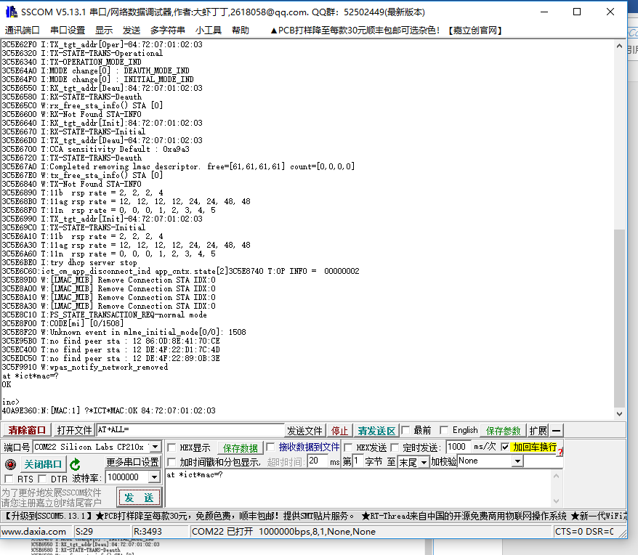
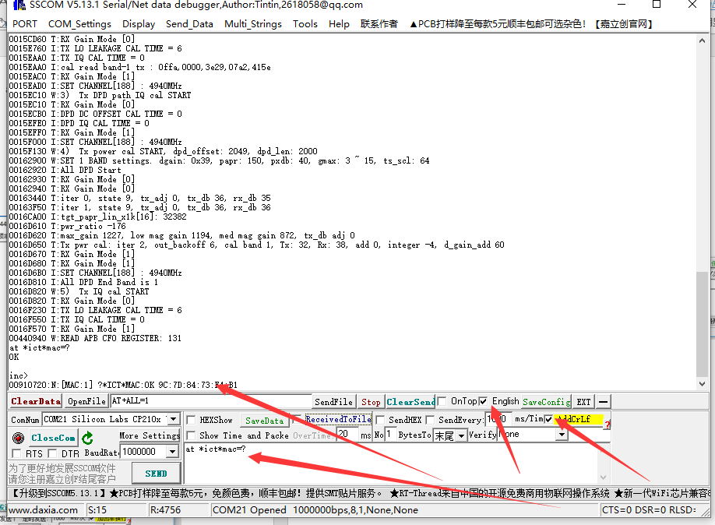

2.Connect Router
at *ict*start doit_newifi doit3305

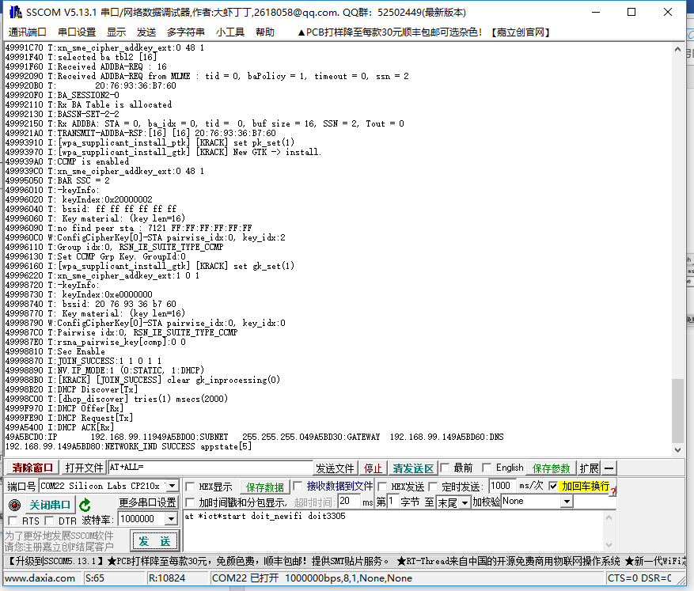
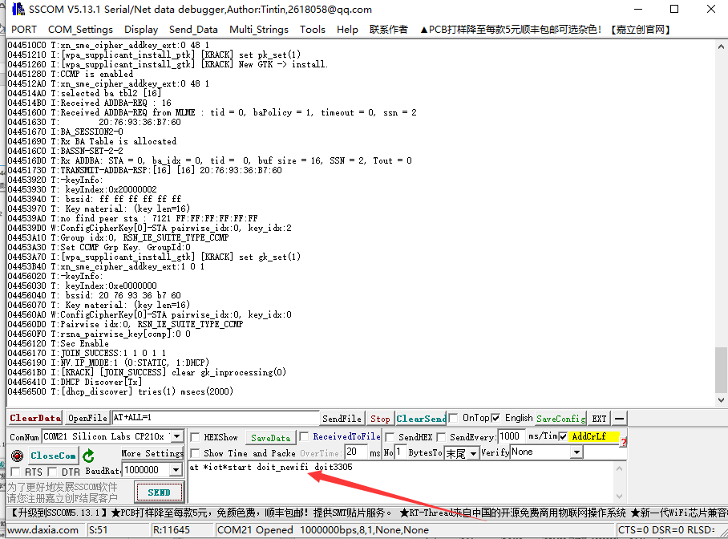

3.停止连接路由
at *ict*stop
